|  |  |  |  |  |  |  |  |  |  |  |  |  |  |  |  |
| --- | --- | --- | --- | --- | --- | --- | --- | --- | --- | --- | --- | --- | --- | --- | --- |
| Goodrich Church of England Primary School Weekly Newsletter | | | | | | | | | | | | |  | | |
| Achieve ∞ Believe ∞ Care | | | | 26th Edition – 16th May | | | | | | | | |
| Dear Parents and Friends,  **Well, Friday is here and the Year Two and Year Six children and staff can breathe again, now that SATs has finished. *Well done,*  to everyone involved, and *thank you* from the rest of us for your extra efforts, especially to Mrs Ridyard and Miss Rice, who have put in a lot of extra time and effort to prepare the children to do their best.**  **Next, the big news. Please, be aware that there will be major staffing changes happening in the new school year, from September. Due to personal and family circumstances, both Mrs Price and Mr Trust will be moving on elsewhere. All of us will miss them and we will be wishing them well at the end of this term. Mr Trust will be moving back to Devon, and Mrs Price will be assisting with the family farming business by Abergavenny. Miss Rice will become Class One’s teacher, which will leave us with a full-time teacher vacancy to fill in Class Two. As a consequence of these changes, Mrs Miles and the Governors are in the process of advertising for this post and for a part-time teacher of Year Three English and Maths. If you have queries regarding how these changes may impact on your children, please feel free to come and discuss it with us.**  **Next week, the Year Six children will be off to Llangorse for their five days of camping and outward-bound activities. They will be accompanied by Mrs Taylor, Miss Marsh, Miss Hutchings and me. Thus, there will be a few rearrangements to the routines of Classes Three and Four: Mrs Ridyard, Mrs Pye and Mrs Dix will be teaching the Year Fives; and Mr Trust and Mrs Pye will be teaching Class Three.**  **Finally, requests, requests! Please:**   * **If you send your child to school with a bicycle, please try to include a bike lock so that we can store as many as possible outside the gate, in the bike rack.** * **Send your child in with a sun-hat and wearing sun-cream for those days that look to be sunny. They spend a lot of time outside between breaks, sports and summer studies.** * **Check that your child has suitable PE kit at school: some of the children need shorts. Their kit can be left in school all week in case of extra opportunities for PE.** * **We are bursting at the seams with lost property: please, come and have a look, and please write names into clothes.** * Special notice: the official school day begins at 8:55. Please, try to have your child in class before the 8:55 bell rings.   **Thank you.**  **Best Wishes.**  **N. Edwards**  **p.p. Mrs Miles** | | | | | | | | | | | | | | | |
| News from the classes | | | | | | | Attendance | | | | | | **This Week** | | |
| **Class One** | We have been learning about different types of materials this week including sheep’s wool, as part of our topic on clothes. | | | | | | **Reception** | | | | | | 91.7 | | |
| **Year One** | | | | | | 97.2 | | |
| **Class Two** | Year 2 have been doing some very tricky work this week and they have been amazing! Year 1 have also been working hard on making their own non-fiction books and designing a theme park. | | | | | | **Year Two** | | | | | | 99.1 | | |
| **Year Three** | | | | | | 91.2 | | |
| **Class Three** | Our Daguerreotype cameras are almost built, but we will need longer to fulfil our mission. The printing inked “negatives” of portraits are interesting! | | | | | | **Year Four** | | | | | | 94.3 | | |
| **Year Five** | | | | | | 94.4 | | |
| **Class Four** | Year 6 have worked extremely hard during SATs week. They have been stars. Year 5 have written some fantastic persuasive letters and solved word problems in Maths. | | | | | | **Year Six** | | | | | | 99.0 | | |
| **Total** | | | | | | 95.4 | | |
| Notices  **Clubs being offered for next half-term:**  **Cricket, Circus skills, Lego, Family Games, Story time, Computers, Soccer, Netball, Multi-sports**  **C:\Users\kmiles\AppData\Local\Microsoft\Windows\Temporary Internet Files\Content.IE5\6C1U1NKI\MC900104730[1].wmfSchool Pupil Tracker Online** | | | | | | | | | | **C:\Documents and Settings\ltaylor\Local Settings\Temporary Internet Files\Content.IE5\00ON26AM\MC900048042[1].wmf**School Prayer  Dear God,  Bless our school.  Bless our teachers.  Bless our pupils.  Bless our families.  Please help us to be kind and help us to always try our best.  Let us remember, as many hands make a house,  So many hearts make a school.  Amen | | | | | |
| Citizen of the Week | | Olivia Sherrington­­ | | | | | | | | | | | | | |
| ClassC:\Users\Karen\AppData\Local\Microsoft\Windows\Temporary Internet Files\Content.IE5\7P6DAE8R\MP900449080[2].jpg Superstars  C:\Users\Karen\AppData\Local\Microsoft\Windows\Temporary Internet Files\Content.IE5\7P6DAE8R\MP900449080[2].jpgC:\Users\Karen\AppData\Local\Microsoft\Windows\Temporary Internet Files\Content.IE5\7P6DAE8R\MP900449080[2].jpgC:\Users\Karen\AppData\Local\Microsoft\Windows\Temporary Internet Files\Content.IE5\7P6DAE8R\MP900449080[2].jpgC:\Users\Karen\AppData\Local\Microsoft\Windows\Temporary Internet Files\Content.IE5\7P6DAE8R\MP900449080[2].jpgC:\Users\Karen\AppData\Local\Microsoft\Windows\Temporary Internet Files\Content.IE5\7P6DAE8R\MP900449080[2].jpgC:\Users\Karen\AppData\Local\Microsoft\Windows\Temporary Internet Files\Content.IE5\7P6DAE8R\MP900449080[2].jpgC:\Users\Karen\AppData\Local\Microsoft\Windows\Temporary Internet Files\Content.IE5\7P6DAE8R\MP900449080[2].jpg | | Class One | Menna DeCloedt  Dyllan Prew  Romy Farquhar | | | | | Class Three | | Charlie Seward  Jack Chaplain  Sophie Curtis  Sophie Davies  Iwan Scrivens  Joe Fraser | | | | | |
| Class Two | All of Year 2 (SATs) | | | | | Class Four | | Max Cronshaw  Isabel Urding  Stone Yates  All of Year 6 (SATs) | | | | | |
| Cloakroom of the week | | C:\Users\Karen\AppData\Local\Microsoft\Windows\Temporary Internet Files\Content.IE5\MHF20M8C\MC900432616[1].pngThe Giving CupC:\Users\Karen\AppData\Local\Microsoft\Windows\Temporary Internet Files\Content.IE5\MHF20M8C\MC900432616[1].png | | | | | | | Housepoints | | | | | | |
| **The Infants** | | **Charlie Pope** | | | | | | | C:\Users\Karen\AppData\Local\Microsoft\Windows\Temporary Internet Files\Content.IE5\D7ULBJI5\MC900336265[1].wmfC:\Users\Karen\AppData\Local\Microsoft\Windows\Temporary Internet Files\Content.IE5\D7ULBJI5\MC900336265[1].wmf | |  | | |  |  |
| Coat Rack Closeup Royalty Free Stock Photography - Image: 23436067 | | School Council Award | | | | | | |
| **Year Two and Year Six** | | | | | | |
| Diary Dates | | | | | | | | | | | | | | | |
| C:\Users\kmiles\AppData\Local\Microsoft\Windows\Temporary Internet Files\Content.IE5\P0HV7FAT\MC900431553[1].png  C:\Users\kmiles\AppData\Local\Microsoft\Windows\Temporary Internet Files\Content.IE5\3L497V70\MC900437615[1].wmfGrow a pound raised £1001.35 | | | | | C:\Users\kmiles\AppData\Local\Microsoft\Windows\Temporary Internet Files\Content.IE5\3L497V70\MC900441822[1].wmfAscension- Simplicity  We live simply, that others may simply live. | | | | | | | | | | |
| T:\Class 3 Beechenhurst 2014\20140404_135338.jpg  **Growing children** | | | | | | Friday 9th May | | | | 2:30 | | Grow a Pound Winner Announced in Celebration Assembly | | | |
| Monday 12th-16th May | | | |  | | SATs / Assessment week | | | |
| Monday 12th May | | | | 7pm | | PTFA Meeting- school | | | |
| Tuesday 13th May | | | | 7pm | | Governors Meeting- school | | | |
| Friday 16th May | | | | 2:30 | | Celebration Assembly  Clubs finish for this half term | | | |
| Monday 19th- 23rd May | | | |  | | Year 6 Llangorse Residential | | | |
|  | | | | | | Thursday 22nd May | | | |  | | Class 2 Tillington Farm Trip | | | |
| Soon we will be revealing our new website. The current website will not be updated as we have no access.  We appreciate your understanding. The blogs are now redundant, and we will look forward to starting afresh in the near future. | | | | | | Friday 23rd May | | | |  | | No Celebration Assembly  End of Summer 1 | | | |
|  | | | | | | | | | | | | | | | |
|  | | | | | | | | | | | | | | | |

|  |  |  |  |  |
| --- | --- | --- | --- | --- |
| Monday 19/05  **Please, ensure that your child’s PE kit is in school on the relevant days.**  **Year 5 Forest Schools all afternoon** | Tuesday 20/05  **Superstars multi-sports club**  **Class 2 PE Dance with Superstars**  **Class 4 PE Games outside**  **Class 3 PE Dance with Superstars** | Wednesday 21/05 | Thursday 22/05  **Superstars multi-sports club**  **Class 1 PE Gym**  **with Superstars**  **Class 4 PE Gym**  **with Superstars**  **Class 3 PE Games outside** | Friday 23/05  **Class 1 PE**  **Class 2 PE**  **Most clubs start in the second week back. Check the clubs letter for details.** |

Infants’ BIG ART with Mrs Miles:

**At the Park**

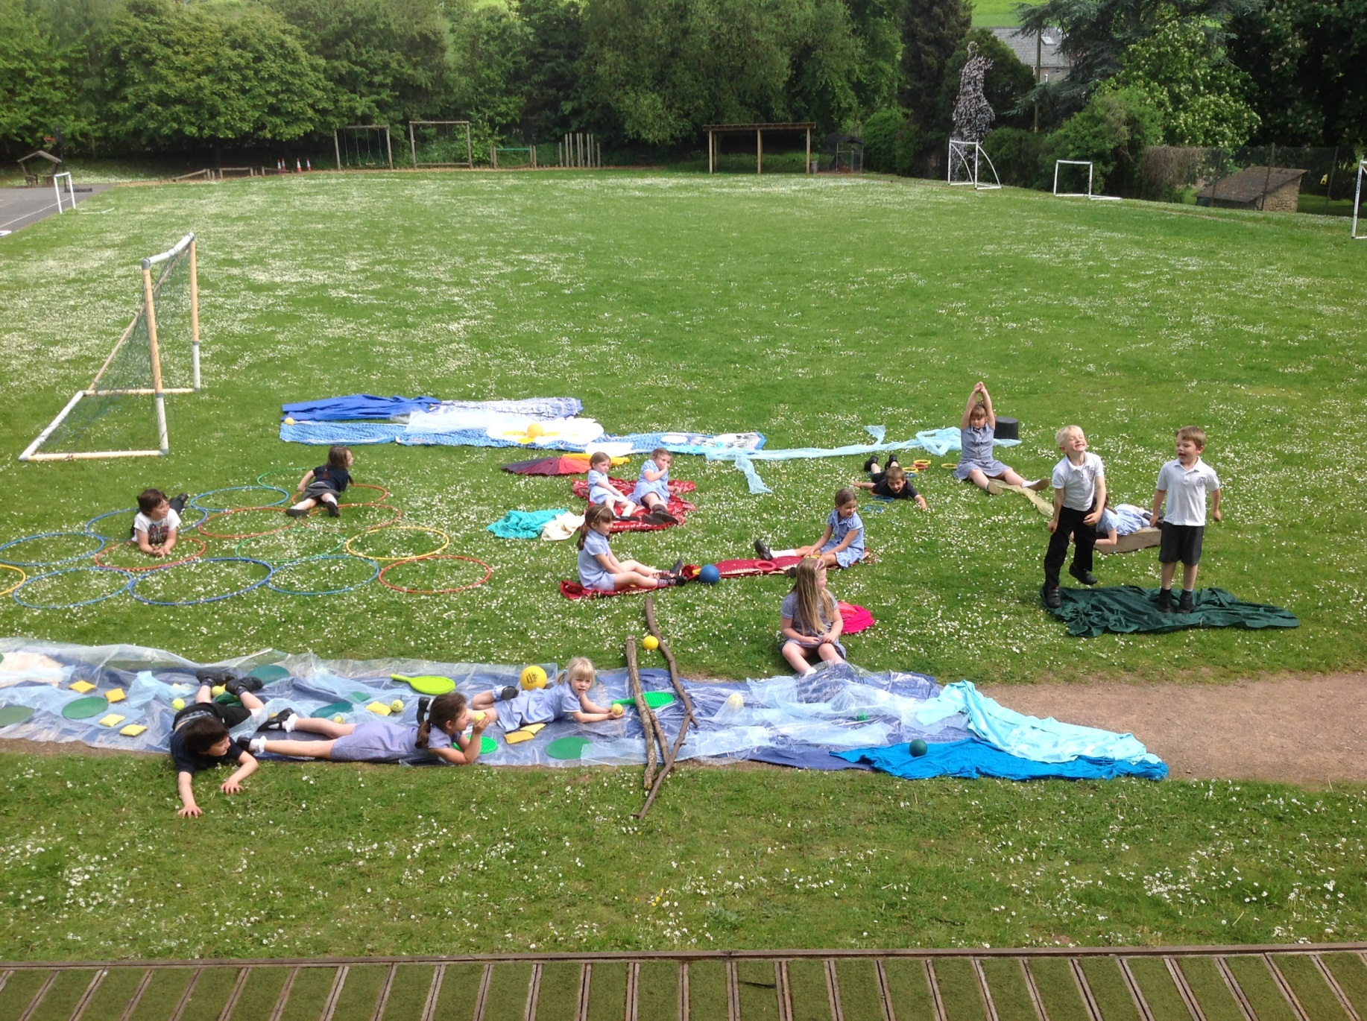

nnnnn