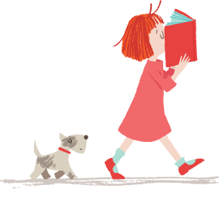
Friday, 27 February 2015

World Book Day

Dear Parents/Guardians

Our World Book day will be on Wednesday 4th March. It has been planned a day earlier because we are having a visit from Pie Corbett, who is a leading figure in the teaching of English and is responsible for ‘Talk for Writing’ which, as you know, is an initiative we have implemented into our school.
On the day, we would like to invite the children to dress up as either a science fiction character or a character from a poem or nursery rhyme. Furthermore, they will need to bring in the book or poem or nursery rhyme that their character is from to share with their class. During our morning assembly, we are hoping Pie Corbett will read us one of his short stories, whilst in the afternoon the children will have the opportunity to show off their costumes in a whole school parade.
We are also running two competitions. The first competition will be for the most imaginative costume and the second competition will be for the best bookmark. The bookmarks will be made in school time. There will be a small prize for the winner and runner-up from each class.
Each child will receive a ‘World Book Day Voucher’ which they can exchange (at a book store) for a special edition ‘World Book Day’ book or put it towards a book of their own choice.
We hope the day will be fun and at the same time highlighting the enjoyment of books and reading.

Yours sincerely

Mrs L Taylor

